

A Project Report

On

**“HEALTH BUDDY”**

Batch Details

|  |  |  |
| --- | --- | --- |
| Sl. No. | Roll Number | Student Name |
| 1 | 20211CSD0034 | SIDDHARTHA G |
| 2 | 20211CSD0036 | ANKITA H S |
| 3 | 20211CSD0049 | KEERTHANA |

**School of Computer Science,**

**Presidency University, Bengaluru.**

Under the guidance of,

Dr.Yamanappa

School of Computer Science,

Presidency University, Bengaluru

**CONTENTS**

1. Introduction about Project
2. Literature Review
3. Objectives

## Methodology

1. Timeline for Execution of Project
2. Expected Outcomes
3. Conclusion
4. References
5. **INTRODUCTION**

A health buddy application is a new virtual resource that is there to help people manage and maintain their overall health and wellness well. It is more of an individualized virtual assistant, which highlights critical health indicators such as nutrient consumption and body mass index, for the achievement of optimal health in the users. Notable features of the application include water consumption reminders and tracking of nutrients, which help users maintain hydration and consume a balanced diet. The application provides timely reminders to ensure that users meet their hydration goals for the day, while the nutrient tracking functionality offers important insights into the quality and balance of meals.

With today's speed of the fast-moving world, it cannot be easy to keep up with perfect health for most people, with poor dietary habits, not enough water drunk, and neglect of taking care of one's wellness. Nutrient deficiencies, unhealthy weight management, and dehydration can stem from negligence of major health indicators. Even though health and fitness applications are doing their best in order to minimize the above-mentioned concerns, most of these applications fail because they give general solutions or stick to just diet or workout plans. The Health Buddy application can be considered as a holistic approach since it offers the above application as customized virtual assistance for tracking vital health metrics such as BMI, nutrient intake, and hydration. The reminders on water consumption and nutrient tracking make the users achieve balanced diets, meet the set targets for their daily hydration, and are aware of the quality of meals and health risks associated. A holistic approach also makes the app allow users to come up with better health habits, manage critical wellness indicators, and keep off potential nutrient deficiencies, making Health Buddy an essential application for long-term management of health and well-being.

1. **LITERATURE REVIEW**

**Advantages:**

* Personalized Health Insights:

Each of these health buddy apps would be able to make recommendations specific to a user, via data such as diet preferences and physical activity levels. Although this is a little-known fact, such level of personalization and embedded usefulness guarantees better engagement from users in their journey towards personalised healthcare.

* Increased Compliance to Lifestyle Regimen goals:

Functionality such as reminders to drink enough fluids or nutrition, nudge the user towards better tracking their health targets. There is evidence that systematic reminders can increase adherence to recommended health behaviours and ultimately improve health outcomes.

* Convenience and ease of access:

The apps are mobile, meaning people have their health data available all day and from anywhere. This ease is most welcome to anyone whose life has robbed them of the time for regular health check-ups.

* Data Management:

Using health buddy applications are not only easy but help in slashing piles of physical documentation into a simple digital dashboard. Efficiency in healthcare delivery can be improved using this digital approach, by reducing waiting times for patients and making appointment scheduling more viable.

* Support with Behavioural Modification

These applications contribute to behavioural modification in the long run by alerting users about their physical activity levels and eating habits so as to improve fitness, health broadly speaking.

**Disadvantages:**

* Dependency on User Input:

Health monitoring applications largely rely on the information that users input regarding the data about their dietary habits and the level of physical activities that people undergo. In case of wrong reporting, there is a probability of producing wrong information that may make the user lose track of their health objectives.

* Limited Scope of Features:

Many of them focus only on the nutritional and physical activities but lack other important aspects, like wellness of the mental health status and chronic disease management. This can easily limit the overall effectiveness of the application in terms of holistic health promotion.

* Problems encountered in Database Usage:

Many applications may not have recent databases of foods. This makes it impossible for users to add new food entries as well as to have an accurate nutrient intake. It could thus impede the ability of the app to provide a precise recommendation and insight into a more comprehensive diet.

* No Real-Time Alerts:

The health tracking application may not provide the real-time alert from the health condition of the users, which can restrain them from giving their response towards critical changes in health. Hence, there is a very high possibility that users might miss essential opportunities for intervention or readjusting their health management strategies when timely alerts are not provided.

* Over-dependency:

Users may become over-dependent on these health tracking applications to manage their health, ignoring conventional methods like consulting healthcare providers or taking physical exercise individually.

**3. OBJECTIVES**

1.⁠ ⁠Boost User Engagement and Perceptual Awareness:

Feature development in health buddy apps will involve educational material on exercise and diet that is designed around the demographical makeup of the user and his health status. This will fill up a knowledge gap in the perception of health metrics and exercise value.

2.⁠ ⁠Health and Medical Specialist Involvement:

Plan the integration of professional health counseling into health buddy applications. This objective will close the gap between the data that users generate themselves and knowledge input from professionals-correct, reliable information on how to best manage their health conditions.

3.⁠ ⁠Improve Data Accuracy and Mechanisms for User Input:

Advanced mechanisms for data entry include speech and image recognition technology for food logging. These mechanisms will contribute to the accuracy of user reported data. This objective will bridge disparities between self-reported health metrics and, therefore contribute positively towards improving the general effectiveness of the application in tracking health behaviors.

4. ⁠⁠Mitigate Privacy and Security Issues:

Health buddy applications should have strong privacy policies and security features to protect user data. Since these factors play a significant role in building user trust that concerns issues linked with leakage of data and unauthorized access, this objective will ensure wider adoption.

**3.EXPERIMENTAL DETAILS/METHDOLOGY**

Softwares used:

Front End Components

1. HTML and CSS
2. JavaScript Frameworks and Libraries

3.Android Studio

Back End Components

1. Node.js

2. Python

3. MySQL

4. MongoDB

**4. METHODOLOGY**

**- DESIGN PROCEDURE**

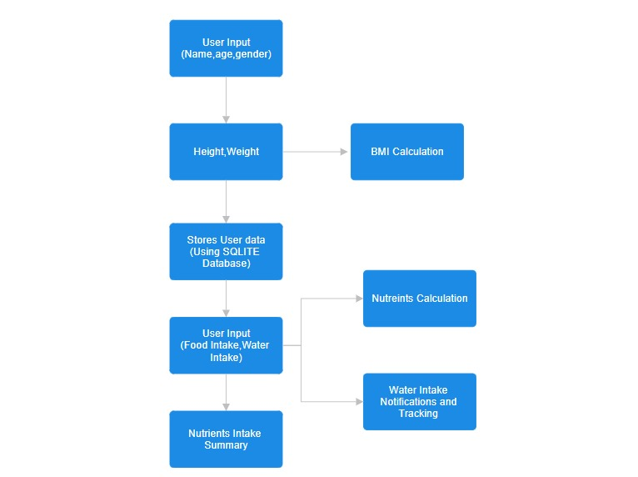

1. **OUTCOMES**

1. Increased Health Awareness

Health buddy apps increase users' knowledge of their daily habits that involve nutrition, hydration, and activity levels. This awareness will help one make further improvements in the right choice related to health, thus improving lifestyles.

2. Increased Personal Accountability

The users are able to monitor water consumption, BMI, and other nutrition health metrics thus being accountable for their health behaviors. Reminders of these health routine activities and monitoring motivate the users to follow the goals set with greater persistence leading to better adherence to health routines.

3. Health Habits

What's impressive about health buddy apps is that they ensure that the more users practice using them, the healthier their lives become. Changes such as diet, exercise, and hydration improvement to increase nutrient tracking, fitness goals, water reminders can all further wellness in the long term.

4. Prevention of Health Problems

Monitoring is possible on health indicators such as weight, activity levels, and in some cases, heart rate or sleep patterns, within an app that can support tracking and noticing potential health issues before they surface. In turn, users can take preventive action or seek appropriate medical attention sooner.

5. Enhanced User Interaction with Health Care

Health buddy apps empower users to take charge of their health through personalized recommendations and in real-time updates. This increased involvement keeps users motivated toward the pursuit of their health and wellness goals.

6. Simplification in Tracking of Health Data

Health buddy apps simplify tracking health data because it's possible to track multiple metrics using just one application. This makes it easier for users to track changes in data over time, correlate them with patterns, and generally become more familiar with health.

7. Improved weight management

Key features, like tracking BMI and calories, enhance weight management. Users can maintain or achieve their ideal weight better because of the set goals and track their development, with less of a chance to have complications associated with obesity.

8. Higher Hydration Levels

Reminders to drink water throughout the day take care of proper hydration. This is the way to offer many health benefits - energy, healthy skin, and functioning of the body at its best.

9. Greater Mental Health and Lower Stress

Many applications that are intended to be for physical wellness also help keep track and monitor progress towards behavioral and lifestyle changes. Seeing changes also positively reinforces an overall mental wellness. Being able to achieve health goals can help relieve stress and make improvements in overall mood.

10. Development of Long-Term Health Goals

It promotes constant engagement in health maintenance by providing users with consistent feedback while allowing them to track their long-term health journey, thereby leading to better long-term outcomes, like reduced risk of chronic diseases and improved quality of life.

**6. TIMELINE OF THE PROJECT/ PROJECT EXECUTION PLAN**

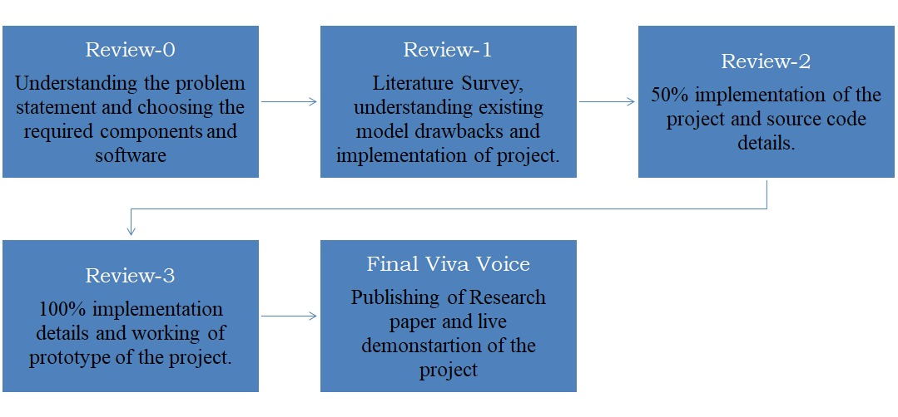

**7.CONCLUSION**

The Health Buddy app serves as a comprehensive tool for personal health management by combining BMI tracking, nutrient analysis, and hydration monitoring into one user-friendly platform. It empowers users to make informed decisions about their diet and lifestyle by providing personalized recommendations based on individual data. Through regular reminders and data-driven insights, the app promotes healthy habits, helping users stay on track with their nutritional needs and water intake. Additionally, by analyzing patterns over time, it can help identify potential health risks and suggest preventive measures, making it an essential companion for long-term well-being.

**8.REFERENCES**

1] The Application of Digital Technologies and Artificial Intelligence in Healthcare: An Overview on Nutrition Assessment (Alessia Salinari,2023).

2] Fluid Intake Monitoring Systems for the Elderly: A Review of the Literature (Rachel Cohen,2021).

3] A WEB APPLICATION ON HEALTH AND FITNESS “MY FITNESS BUDDY” (Avi Kadam,2021).

4] Mobile Based Applications for Nutritional Significance: Indian and Global perspective (A Irshad,2019).

5] Time-Restricted Eating Alters Food Intake Patterns, as Prospectively Documented by a Smartphone Application (Samar Malaeb,2020).